Career in Construction – Luke Boekestyn

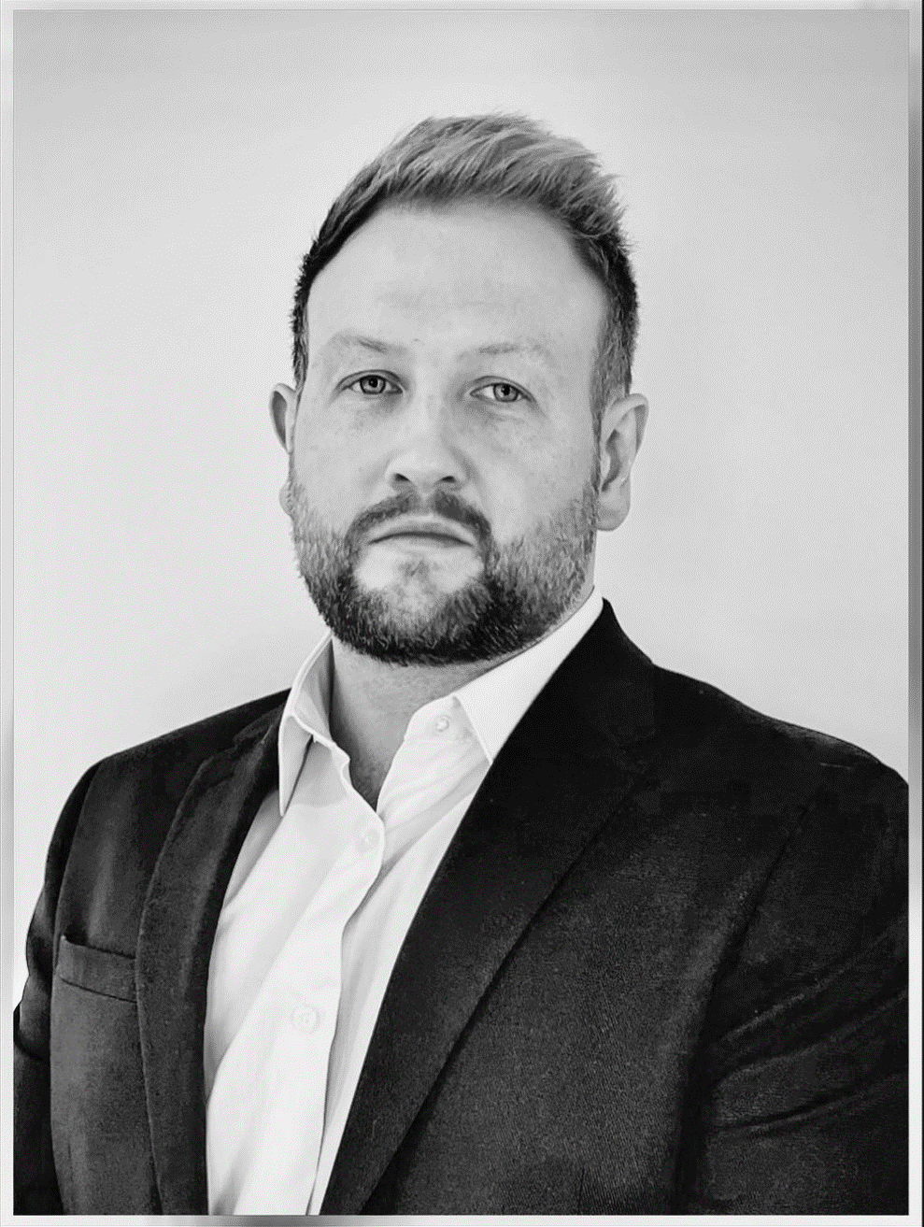

What A- Levels you studied at SGS
Psychology
English Literature and Language
Business Studies
PE

How long were you at SGS
2001 to 2007

Your time at SGS, favourite teachers, lessons you enjoyed:
Always had a soft spot for the PE department especially as they took me in for some work experience after I’d left Sixth Form – special shout outs to Mr Crane and Mr Venables who were also good to chat with at the recent careers fair – always nice to be remembered for the good and the bad! My form tutor in year 8 was Mr Fuller and also taught me Biology, not everyones cup of tea but was certainly mine. Also friendly with Mrs Leadbeater who I’m still very much in touch with now!
Where you went after SGS, Uni etc:
After leaving SGS I went into full time employment about 6 months after with Burmor Construction.

Job/Jobs?? About them:
16 years later I’m a Director/Shareholder of Burmor Construction, I’ve spent 10 of those 16 years here but there was a break in the middle where I moved around a couple of companies gaining other valuable construction related experience with 2.5 years in London working on brownfield regeneration sites. In that time I’d been to Nottingham Trent University on a 5 year apart time degree to get my Quantity Surveying and Commercial Cost Management degree.

I am now the Enterprise Co-Ordinator at SGS.

