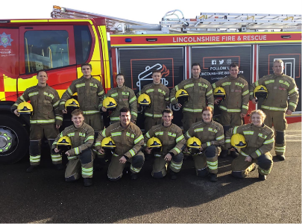
Fire Fighter Training Course
My name is George Thornley and I was a student at Spalding Grammar School from 2014-2019. I also attended the sixth form from 2019-2021 where I studied Physical Education, Psychology and Business Studies. In my later years of school, I had an ambition to become a fire fighter as my occupation. Mrs Hoyles, who does careers guidance at Spalding Grammar supported me on this ambition by guiding me onto the right path to get started. This included helping with personal statements/CV and providing me with useful information on the fire service and what qualities are needed to succeed. Therefore, I would like to thank her for her support. There are many stages that need to be completed in order to become firefighter that begin even before the training such as interviews, physical assessment days and medical tests. When I had successfully completed these procedures, I was allocated a position on a Fire Fighter training and development course. This was an intense course that took place in Lincoln (Waddington Training Centre) beginning on September 12th, ending November 18th. The training was mentally and physically challenging that was also very theory based. On November 18th I officially passed out as a Fire Fighter after numerous assessments to put my ability to the test. To the right is a picture of me and the 11 other candidates that qualified to become a fire fighter in various areas across the county such as Sleaford, Boston and Caistor.
Training: Core Skills
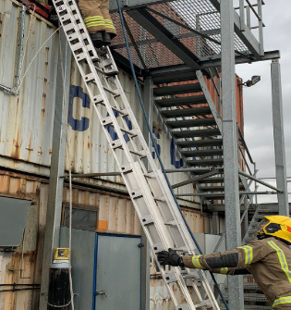
The beginning of our training was an introduction to fire fighting where we learned all the core skills required to be safe and an effective fire fighter. A skill that was heavily practised was ladder pitching. This involved a team of 4 lifting, sighting and pitching a 13.5 metre or 9 metre ladders quickly and accurately to a place where our Watch manager instructs us to. We also then learnt how to work off a ladder using different hose reels and learning timed critical rescue from a building. Pump basics were also a key part of core skills training where we learnt the basic mechanics of the inside of the fire engine and how to operate the water. This also involved using and building hydrant from below the ground to be used as a water source. We also studied Trauma care which involves following specific procedures on what to do if someone is not breathing/unconscious. CPR was learned and examined in the core skills segment of training. We also touched on water awareness and rescue using wade poles in still water to retrieve someone trapped or stuck in open waters such as rivers or lakes. We also learned 9 knots including a double sheet bend and half hitches that would be used for core skills such as creating a hard suction pipe or hauling loft a hose branch to the top of a building.
BA- Breathing Apparatus
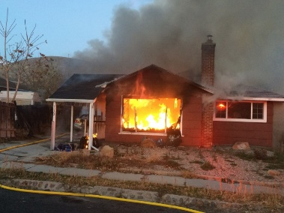
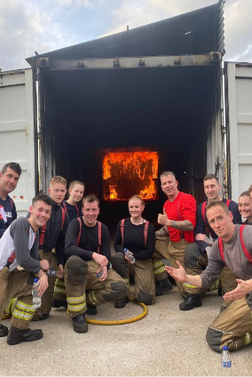
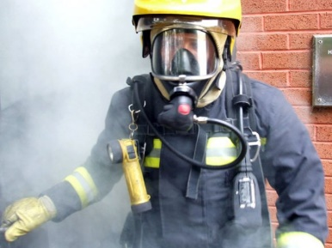
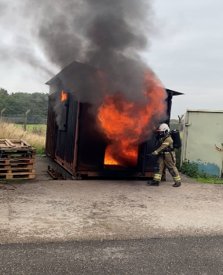
BA was the hardest but most fun part of the entire training course. BA stands for breathing apparatus. As a fire fighter we wear BA to enter hazardous environments such as a house fire to ensure we are safe and can breathe oxygen with the aim of either saving people from burning buildings or simply finding the source of the fire and putting it out using the equipment we have. A BA team is a team of 2 BA wearers who work simultaneously doing different jobs. We learnt how to efficiently search entire building compartments in complete darkness and extreme heat conditions with the aim of finding casualties which were dummies scattered across the buildings. As a BA team 1 hose reel was brought into the building with you, which number 2 would constantly have to reel in. BA was very physically and mentally challenging, however was extremely rewarding. We also heavily invested into the science behind fire such as how it starts and how it spreads. This included definitions such as combustion, backdraughts, flashovers, and heat capacity. We learnt how to use communication using the spirocomms which are connected to the breathing mask. Below are some pictures linked with the BA segment of the course!
RTC- Road Traffic Collisions
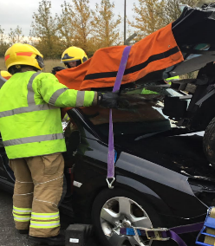
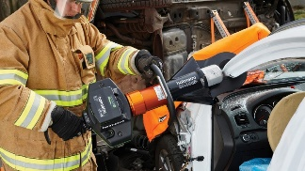
The RTC section was the final part of the training. The overall objective was learning to deal with a traffic collision the best you can using the appropriate equipment provided. Fire Fighters are now legally obliged to attend all RTC incidents due to the advanced and specialist equipment we have at our disposal. These include holmatro tools such as spreaders, cutters and rams that are powered hydraulically which means they can power through any material which makes it useful to rescue trapped people from vehicles. We learnt how to stabilise a vehicle, which means it will not move while operating on it, using blocks, chocks, and stab fasts. We also learnt how to efficiently cut through glass and car metals in order to extricate casualties from the vehicle they are in. Casualty care was also a large part of the RTC course. This involved how to look after someone who’s been in an immediate RTC and make them feel safe and comfortable using communication and applying O2 masks. Below are some of the tools, equipment and fake incidents we worked on during our training.
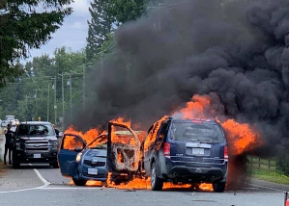
As I qualified as a fire fighter on the 18th of November, I now work at the fire station at Spalding serving and protecting the community. I respond to an alert that can go off at any time of the day or during the night. As soon as my alert goes off, I drive to my station in Spalding and meet my crew to then respond to whatever incident the world throws at me that day. I have so far (as of writing this article on the 26th of November) responded to 3 shouts. One included a skip fire at a recycling company, and another was an electrical fire at a factory. A fire fighter is a brilliant and rewarding job with immense amount of excitement and adrenaline added. It is a pleasure to serve the community as a fire fighter knowing I can make a difference to someone’s life working with my crew at Spalding. I would recommend this job to anyone who is physically fit, has good dexterity and practical skills and has a large amount of determination, drive and passion for the fire service.

