Alumni
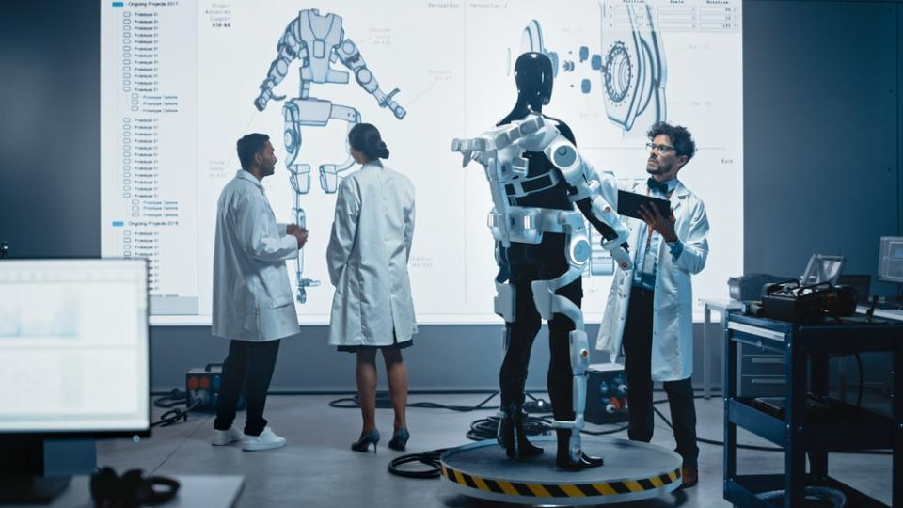

The Experiences of a Biomedical Engineering Student
Hello! My name is Molly, I studied at Spalding Grammar School 6th form 2016 -2018. If you are reading this, you have probably either decided that you would like to study Biomedical Engineering or you have no idea what you would like to do. I was definitely in the second category (and still am!) during my school career, but hopefully reading this will give you an insight of what it is like to study Biomedical Engineering and help you make some of those all important decisions.
For my A levels I studied Maths, Further Maths, Physics and Product Design with the anticipation of studying architecture at university. Although I soon realised that this wasn’t for me and began to pursue a career in Biomedical Engineering, hoping that I could combine my passions for maths, being creative and helping others. I applied to study at Imperial College, Loughborough, Sheffield, Warwick and Nottingham Trent, and managed to earn a place to study at Imperial College. I also applied to the Dyson degree apprenticeship.
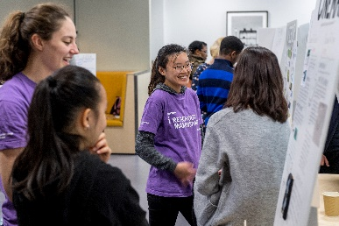
Studying in London at Imperial College was a fabulous experience. Imperial is a STEMM focused university so everyone there is super passionate about science, so it is a really motivating environment to be in. While I was studying, I got involved with a few societies including the Bioengineering society (where I was the Wellbeing Events Coordinator for one year), archery and canoe. However, I would definitely recommend getting involved with as many societies as you have time for. They are a great way to meet lots of people and have some chill time away from your studies. It was also great fun to take on a committee position and have a say in how the society is run and put my own spin on some of their events.
Also, while I was studying, I worked with Imperial College Outreach, I think most universities have something similar. This involved being a mentor mostly for GCSE and 6th form students, but also younger students and the general public. The work ranged from one off events, to in the workshop, to weeklong summer schools. Explaining concepts to younger students consolidated my knowledge and I got to know lots of different people from lots of different backgrounds. Sometimes I was even more excited about the activities than the students!
London was such a great city to study in as both the city itself and the student body is very international, so I enjoyed getting to know other cultures. There is also always something going on in London so there really is no excuse to be bored, there are always plenty of live music events, exhibitions or lectures going on. I mention lectures as many of the engineering institutions, such as IMechE and the IET offer free evening lectures, where you can hear about current research topics. It is also a great way to get to know different professors if you would like to do a research project. Imperial also hosted the BioMedEng19 conference, which I volunteered at, this was also an excellent opportunity to learn about current research topics.
During the summer break after my 2nd year, I worked with a lecturer and some other students to design a course to be taken by Design Engineering students. This was very interesting as I got to see classes from the lecturers’ perspective. I found the placement very enjoyable as I had the opportunity to learn about a subject outside of my field and use my creativity to design interesting workshops for other students. I was also asked to help teach the course, which was very rewarding and led me to consider teaching at some point in my career.
After my 3rd year I worked at a start-up company who are developing a device for magnetic blood filtration. While I was there, I worked on a project to design a piece of equipment to help them verify part of their device. This involved working with software which could simulate magnetic fields. I also did some prototyping, so I used a CAD software to do some 3D printing. I heard about this company through the careers advisor in my department at university, but I also went to lots of careers fairs at university and looked on job websites when I was looking to apply for an internship. I probably applied to about 30 companies, heard back from 5 and got 2 offers, so a lot of work to get a summer job but very much worth it.
And as for my course itself, Biomedical Engineering is quite a broad field. I got to study many different topics to find out which I like, these include electronics, programming, mechanics, physiology and cellular biology. In my third year I chose to specialise as a mechanical engineer which made my studies much more focused. Aside from lectures we also have labs and get to do some project work. One of my projects was designing a system to help visually impaired swimmers know where the end of the lane is. This involved using microprocessors like Arduino and Raspberry Pi with a colour detection camera and small vibrating coins. Another project was about how we can determine the nature of a child’s injury. For this, I worked in the workshop to create a metal model of the skeleton which was then used to replicate a fall in an environment with motion capture (like they use for animated films) and force plates. We then used the data and a little bit of maths to predict if a bone could have broken in this scenario.
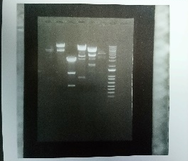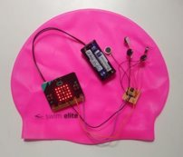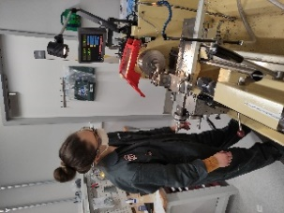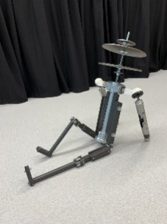
This year I am doing a year abroad and studying at ETH Zurich in Switzerland. If you would have asked me about living abroad when I was at SGS, I would have said no way. But I applied since I did not want to think in 10 years, “what if?”. And so far, it is brilliant, and I am so glad that I applied and got to come! I think it so valuable to experience life from different cultures and learn about different perspectives and grow yourself by stepping out of your comfort zone. My study programme here is a lot more flexible, so I have been able to pick courses that really interest me and was able to choose a supervisor for my Master’s project quite freely. For my Master’s project I will research the manufacture of magnetic microneedles which in the future could be used for drug delivery. I will work on this for 6 months full time, before going back to London to graduate in October.
And after that, well who knows! Coming to Zurich has opened many doors, so perhaps I will stay in mainland Europe and work as a Biomedical Engineer, or maybe I will look for work in the UK. I am still not sure which sector of bioengineering, maybe drug delivery or rehabilitation. Or I am also considering engineering consulting… I hope to have a better idea after working on my Master’s project, so I will look for something that suits me then. But thank you for taking the time to read my experiences, and if I can offer any advice, please feel free to contact Careers.
Molly Abraham

