SGS DT A level - Product Design Transition Work

As designers we need to be aware of products, structures and interiors that could be made more effectively or improved for their target market, or the future of our planet. We need to think broadly about products that are used by others and not just ourselves. We need to gather inspiration from a wide range of sources in all things and try to be open-minded.
Task 1
Study the images below. Choose one to analyse. Analyse the product fully, highlighting its weaknesses and strengths. Present this information in a powerful and creative manner.
Now redesign the product in a way that addresses its weaknesses and makes significant improvements for its intended user/consumer. Include detailed drawings, dimensions, colour and annotation that elaborates on the products materials and the way in which it could be manufactured.
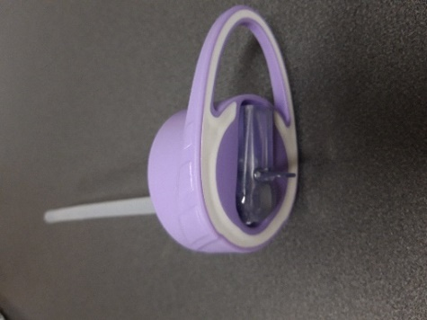
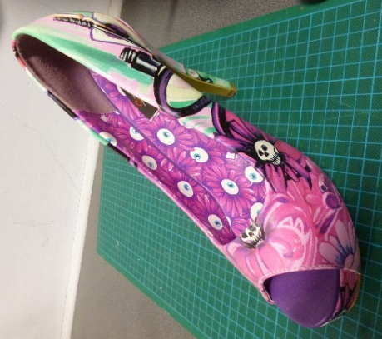
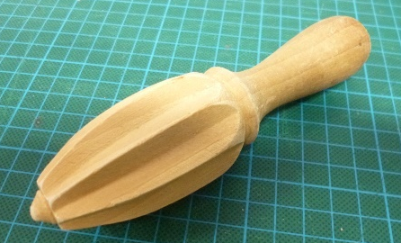

Wooden juicer
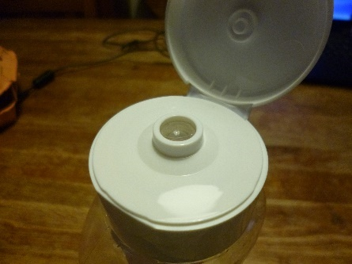

Iron Fist stiletto Water bottle lid

Tomato sauce bottle lid

Task 2
Choose a product from one of the designers below and evaluate how you think the designers have addressed form and function in relation to the product you have found. Start by writing what form and function mean and then include a picture of the product you have chosen. Annotate the key characteristics that represent the style and include other examples if you feel necessary.
- Philippe Starck – Post modernism
- Ettore Sottsass – Memphis design movement
- Raymond Lowey – Streamlining
- Wally Ollins – Graphical branding
- Barber and Osgerby – Modern 21st century design

