
Preparing for Criminology
Open University FREE online courses:
The Open University have a huge number of free online course that you can study. They tell you how long they take and give you an outline of what is included. You also get a free statement of participation on completion. Take a look and see if any take you interest.

An introduction to crime and criminology
https://www.open.edu/openlearn/society-politics-law/introduction-crime-and-criminology/content-section-0?active-tab=description-tab

Below are a range of documentaries/ films/ books/ online lectures/ news stories and articles linked to criminology…

Complete a series of reports about criminology in the media. There are many TV Shows, Films, Books, Magazines and Websites about Criminology - it will be your task to watch, read and research different areas of Criminology and write a short report about each of them (see page 3-4).

Title | Origin | Link (if available)
Amanda Knox | YouTube | https://www.youtube.com/watch?v=erla7Ley4Tw
Any documentaries in the BBC Series- Love and Hate Crime |  | https://www.bbc.co.uk/programmes/p05r3vw3/episodes/player
Ted Bundy | Netflix
I am killer | Netflix
Mindhunter | Netflix
What makes a Murderer | All 4 | https://www.channel4.com/programmes/what-makes-a-murderer
Mods & Rockers | YouTube | https://www.youtube.com/watch?v=rFL54R9g5Io
Jamie Bulger | YouTube | https://www.youtube.com/results?search_query=jamie+bulger+documentary
Stephen Lawrence | YouTube | https://www.youtube.com/watch?v=ZsHwKPE0mjU&t=28s
Timothy Evans  (10 Rillington Place) | YouTube | https://www.youtube.com/watch?v=YSL_zNIxM-k

Online Lectures
Title | Origin | Link (if available)
Can the Law Keep Up with Changes in Society? | Gresham College | https://www.gresham.ac.uk/lectures-and-events/law-changes-in-society
Prison and why we send people there: Does it work? Should it work? | Gresham College | https://www.gresham.ac.uk/lectures-and-events/prison-and-why-we-send-people-there-does-it-work-should-it

 | 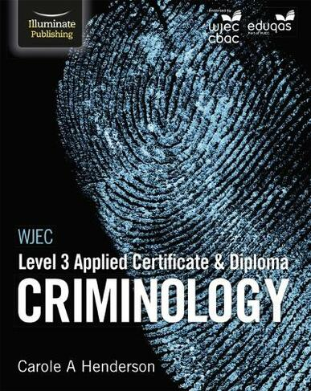  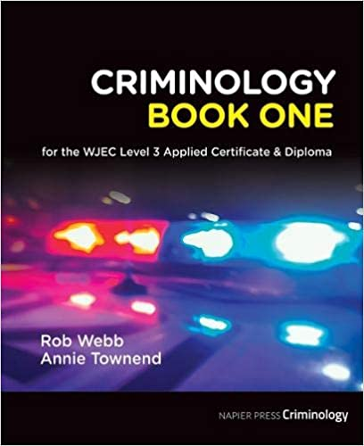  Student Textbooks:

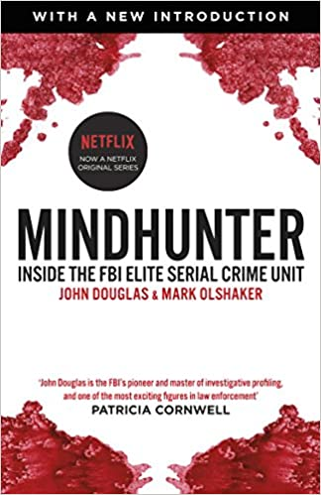
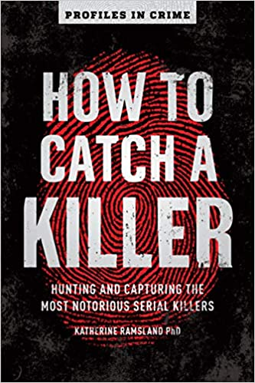
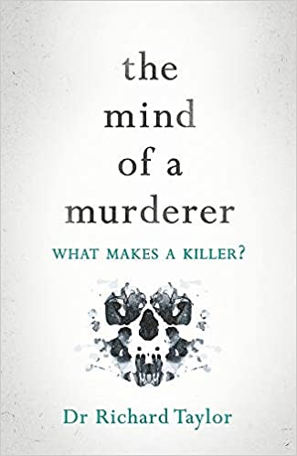
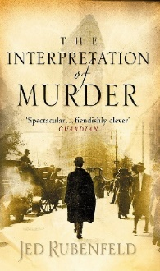
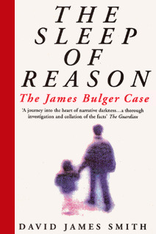
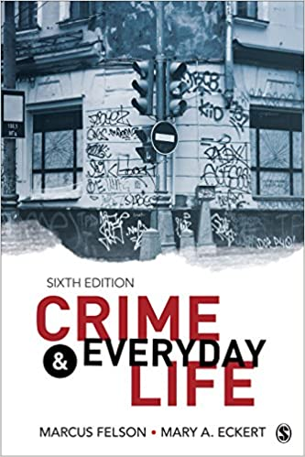
Other relevant books you might find interesting:

 |   BBC News  Please read daily and research local examples of crimes. Build a case file.

 | Old News  Profile these old news stories: What do they tell us about why crime is committed or the campaigns started to change the law?  Influence of Drill Music- https://www.bbc.co.uk/news/entertainment-arts-51459553  Ann Ming (Campaign)- https://inews.co.uk/culture/television/julie-hogg-murder-mother-ann-ming-killer-billy-dunlop-catching-britains-killers-bbc-two-815255  Sarah’s Law (Campaign)- https://www.bbc.co.uk/news/uk-25489541

 | 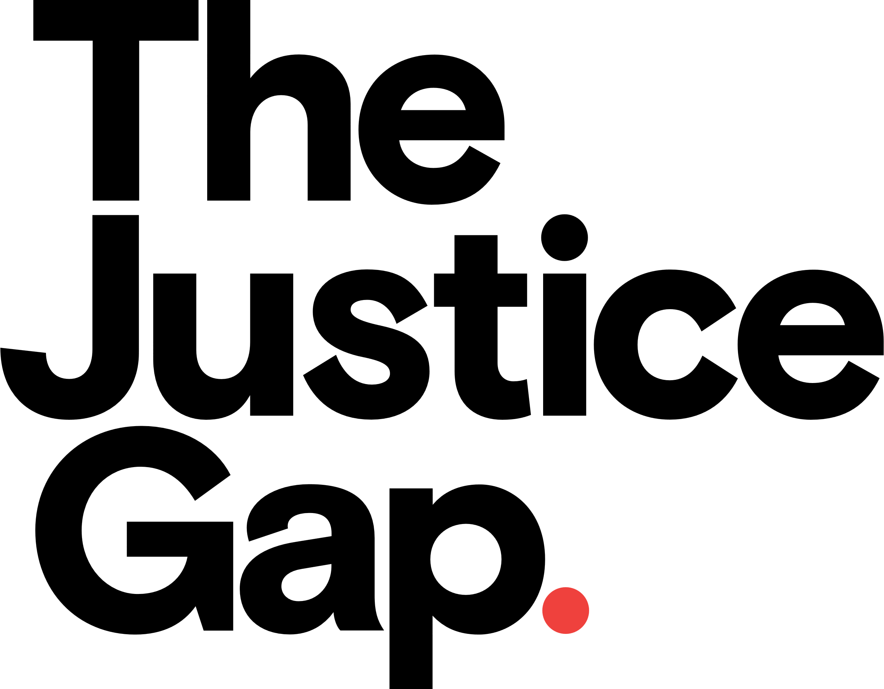  The Justice Gap is run by a journalist who has written about law and justice for 15 years. This article is about England and Wales’ high prison population.  https://www.thejusticegap.com/england-and-wales-has-highest-imprisonment-rates-in-western-europe/

 | Criminology Podcasts: warning some content maybe explicit  Crime Tapes: https://player.fm/series/crime-tapes  Criminologyhttps://player.fm/series/series-2409410  Social Science Bites https://player.fm/series/social-science-bites

Course information:
The WJEC Applied course consists of the following units:
UNIT 1: Changing Awareness of Crime
UNIT 2: Criminological Theories
https://www.wjec.co.uk/media/ievn4ihq/applied-certificate-in-criminology-specification-from-2015.pdf

Criminology Media Project

Title:

Type of media:

Link to Criminology:

Media outline and image:

Review with links to Criminology:

Accuracy | Enjoyment | Relevance to the subject | Has it improved your understanding? | Would you recommend it?
/10 | /10 | /10

Step-by-Step Guide to How to Write a Review https://edusson.com/blog/how-to-write-movie-review

Beginnings are always the hardest. This is the point where you set the pace and determine how to approach this assignment in the most efficient manner. Here are some useful tips to kick-start the movie review writing process:

- Watch the movie /documentary/ Lecture or read the book/ article with your full focus and take notes of both major and minor events and characters. It’s a mistake to rely on the power of your memory only, there’s always something we overlook or forget.
- Carry out a thorough research. Watching/ reading isn’t enough, research is equally important. Look for details such as key names, motivation, locations, plot, characterization, historic events that served as an inspiration (if applicable). Basically, your research should serve to collect information that provides more depth to the review.
- Draft an outline that you will follow to write the review in a concise and cohesive fashion
- Include examples for claims you make. Where the plot is relevant to psychology, mention an example of a situation or scene when that was evident.
- Analyze the media after you watch/ read it. Don’t start working on the review if you aren’t sure you understand what happened. Evaluate the media chosen from beginning to an end. Re-watch/ read it, if necessary, if you find some parts confusing. Only when you understand events that happened will you find it easier to create the review.

How to organise your review:
- Introduction (with title, release date, background information)
- Summary of the story
- Links to psychology, being specific about the area of psychology, with examples.
- Opinion (supported with examples and facts from the story)
- Conclusion (announcing whether the filmmaker was successful in his/her purpose, re-state your evidence, explain how the motion picture was helpful for providing a deeper understand of course topic)

