
Preparing for A Level Law
Open University FREE online courses:
The Open University have a huge number of free online course that you can study. They tell you how long they take and give you an outline of what is included. You also get a free statement of participation on completion. Have a look at one of the courses below.
Starting with law: An overview of law: https://www.open.edu/openlearn/society-politics-law/starting-law-overview-the-law/content-section-0?active-tab=description-tab
The law-making process in England and Wales: https://www.open.edu/openlearn/society-politics-law/the-law-making-process-england-and-wales/content-section-0?active-tab=description-tab
Judges and the Law: https://www.open.edu/openlearn/society-politics-law/judges-and-the-law/content-section-0?active-tab=description-tab
Choose from the list: https://www.open.edu/openlearn/search-results?as_q=criminal+law

Course information:
The AQA Law course consists of the following content:
- The nature of law and the English legal system
- Criminal Law
- Tort
- Law of Contract
https://filestore.aqa.org.uk/resources/law/specifications/AQA-7162-SP-2017.PDF


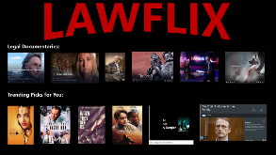
Below are a range of documentaries/ films/ books/ online lectures/ news stories and articles linked to Law…

Complete a series of notes about the different legal knowledge you gain from the information links available in this booklet.

Use the starter sentence…. ‘What does the information tell us about….’ and consider whether the information applies to the English Legal System or Criminal Law. Be clear on the document which media you gained the information from, noting down key words, phrases and contain your information to one side of A4. (An example has been provided for you on page 3.)

Title | Origin | Link (if available)
Law Making Process | Parliament | http://www.parliament.uk/education/teaching-resources-lesson-plans/an-introduction-to-parliament-ks3-5-video/
HARD talk interview with Lady Hale | YouTube | https://www.youtube.com/watch?v=i1VozJR_jC8&t=414s
What is the UK Supreme Court? | YouTube | https://www.youtube.com/watch?v=PZtYENfNa7k  https://www.bbc.co.uk/news/uk-49663001
The Case of Sally Challen | iPlayer (BBC) | https://www.bbc.co.uk/iplayer/episode/m000c65v/the-case-of-sally-challen
12 Angry Men | YouTube - play | https://www.youtube.com/watch?v=ngbEpZ0tTjI
An Introduction to Criminal Liability | YouTube | https://www.youtube.com/watch?v=R3SKAn93CnU&t=7s

Online Lectures
Title | Origin | Link (if available)
Can the Law Keep Up with Changes in Society? | Gresham College | https://www.gresham.ac.uk/lectures-and-events/law-changes-in-society
The Rule of Law: Good for the Economy? | Gresham College | https://www.gresham.ac.uk/lectures-and-events/the-grays-inn-reading-the-rule-of-law-good-for-the-economy
The Legal Profession- regulating for independence | Gresham College | https://www.gresham.ac.uk/lectures-and-events/the-legal-profession-regulating-for-independence
Access to Justice: Keeping the doors open | Gresham College | https://www.gresham.ac.uk/lectures-and-events/access-to-justice-keeping-the-doors-open
Parliament website includes lots of information about law- making and interpretation.
http://www.parliament.uk/
The Justice Gap is run by a journalist who has written about law and justice for 15 years.
https://www.thejusticegap.com/category/criminal-justice/
  Student Textbooks: | 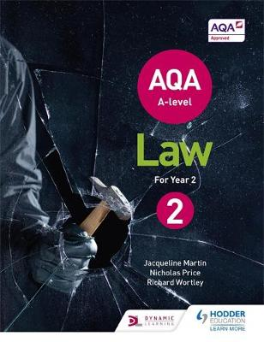  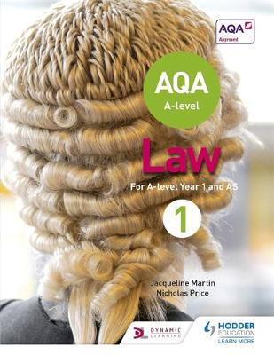

Other relevant books you might find interesting: | 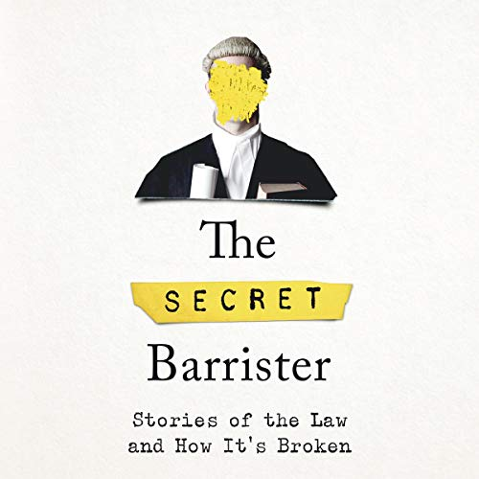  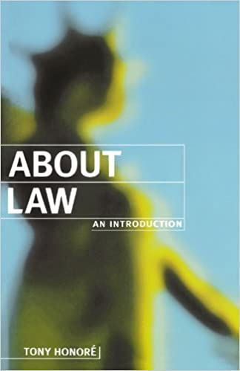  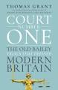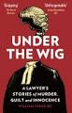

 |   BBC News  Please read daily and research national discussion of the key topics found at the end of this booklet. Build a case file for developments/ discussion of the law in these areas.

 | Law Podcasts:  BBC Law in Action: https://www.bbc.co.uk/programmes/b006tgy1  Law Pod UK: https://audioboom.com/channels/4911918

What does the information tell us about….?

‘Statutory Interpretation’ are the rules of language used by judges in the English Legal System.
‘The Literal Rule’ is one of the methods used by judges and judges use it by……….



